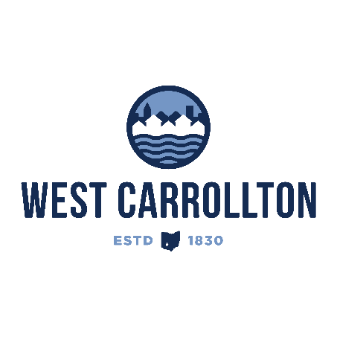

PLANNING COMMISSION
NOTICE OF PUBLIC meeting

Case No.: PUD-25-1_DSP 26-2
Barrett Site Plan

Meeting Date: Thursday, March 19, 2026

Time: 6:30 p.m.

Place: City Council Chambers – Civic Center, 300 E. Central Avenue

Notice is hereby given that a Public Meeting will be held by the City of West Carrollton Planning Commission in the City Council chambers at the Civic Center, located at 300 East Central Avenue, on Thursday, March 19, 2026, at 6:30 p.m., to consider an application by Barrett Paving Materials Inc., PO Box 13671, Dayton, Ohio 45413, to approve a detailed final site plan for mineral extraction on property located at 5058 and 5174 Farmersville-West Carrollton Road, comprising approximately 56 acres and 82 acres respectively.

The proposed application may be examined at the City of West Carrollton Planning and Community Development Department located at 300 E. Central Avenue from Monday through Friday, 8 a.m. to 4:30 p.m., or on the City’s website at www.westcarrollton.org/planning-commission. If you have questions or need more information, please email plan@westcarrollton.org or call 937-859-5783.

