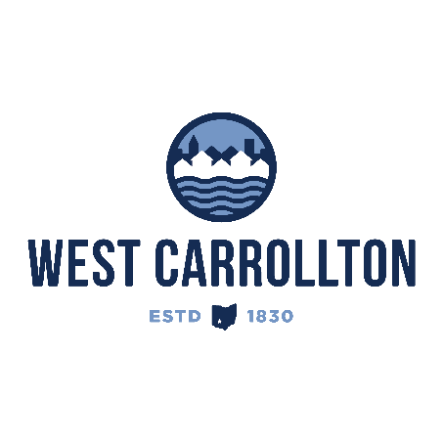

PLANNING COMMISSION
NOTICE OF PUBLIC meeting

Case No.: S-25-4
1000 E. Dixie Drive

Meeting Date: Thursday, December 18, 2025

Time: 6:30 p.m.

Place: City Council Chambers – Civic Center, 300 E. Central Avenue

Notice is hereby given that a public meeting will be held by the City of West Carrollton Planning Commission at the Civic Center located at 300 East Central Avenue on Thursday, December 18, 2025, at 6:30 p.m., to consider an application by the City of West Carrollton, 300 E. Central Ave., West Carrollton, Ohio 45449, for the replat of lot 2500, combining with vacated right of way to create 3 new lots. This also includes the dedication of 0.038 acres as right of way for a total acreage of 3.104 acres.

The proposed application may be examined at the City of West Carrollton Planning and Community Development Department located at 300 E. Central Avenue from Monday through Friday, 8 a.m. to 4:30 p.m., or on the City’s website at www.westcarrollton.org/planning-commission. If you have questions or need more information, please email plan@westcarrollton.org or call 937-859-5783.

