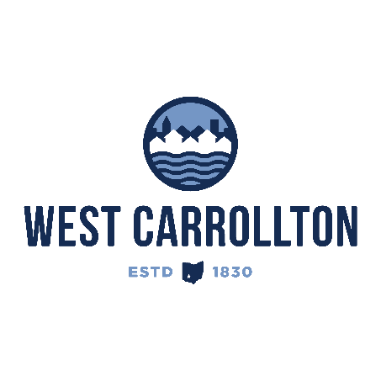

PLANNING COMMISSION

NOTICE OF PUBLIC Meeting

Case No.: SP-25-2
5883 Student Street

Meeting Date: Thursday, November 20, 2025

Time: 6:30 p.m.

Place: City Council Chambers – Civic Center, 300 E. Central Avenue

Notice is hereby given that a public meeting will be held by the City of West Carrollton Planning Commission at the Civic Center located at 300 East Central Avenue on Thursday, November 20, 2025 at 6:30 p.m., to consider an application by Mark Wiseman, Levin-Porter Architects, 3011 Newmark Drive, Miamisburg, OH, 45342, agent for the property owner, West Carrollton Board of Education, 430 E. Pease Ave., West Carrollton, OH, 45449, requesting approval for amendments to the approved landscaping plan for the new Middle School-High School property.

The proposed application may be examined at the City of West Carrollton Planning and Community Development Department located at 300 E. Central Avenue from Monday through Friday, 8 a.m. to 4:30 p.m., or on the City’s website at www.westcarrollton.org/planning-commission. If you have questions or need more information, please email plan@westcarrollton.org or call 937-859-5783.

