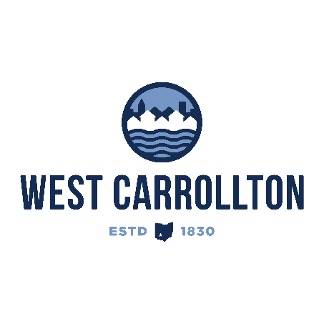

PLANNING COMMISSION

NOTICE OF PUBLIC MEETING

**Case No.:** S-25-2

**Meeting Date**: Thursday, October 16, 2025

**Time**: 6:30 p.m.

**Place:** City Council Chambers – Civic Center, 300 E. Central Avenue

Notice is hereby given that a public meeting will be held by the City of West Carrollton Planning Commission at the Civic Center located at 300 East Central Avenue on Thursday, October 16, 2025 at 6:30 p.m., to consider an application by Bethel Baptist Church, 434 Wilson Park Drive, West Carrollton, Ohio 45449, for the replat of City Lots 3569 and 4170 to split part of lot 4170 and combine it with lot 3569, while also dedicating part of lots 3569 and 4170 as public right-of-way.

The proposed application may be examined at the City of West Carrollton Planning and Community Development Department located at 300 E. Central Avenue from Monday through Friday, 8 a.m. to 4:30 p.m., or on the City’s website at [www.westcarrollton.org/planning-commission](http://www.westcarrollton.org/planning-commission/). If you have questions or need more information, please email [plan@westcarrollton.org](mailto:plan@westcarrollton.org) or call 937-859-5783.