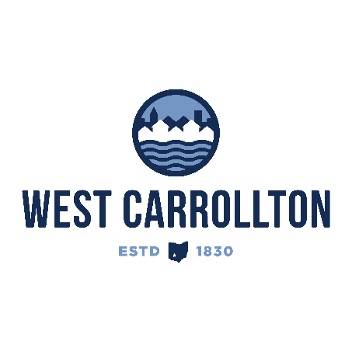

PLANNING COMMISSION

NOTICE OF PUBLIC meeting

**Case No.:** CC-25-1

1000 E. Dixie Drive

**Meeting Date**: Thursday, November 20, 2025

**Time**: 6:30 p.m.

**Place:** City Council Chambers – Civic Center, 300 E. Central Avenue

Notice is hereby given that a public meeting will be held by the City of West Carrollton Planning Commission at the Civic Center located at 300 East Central Avenue on Thursday, November 20, 2025, at 6:30 p.m., to consider an application by Skilken Gold, 4270 Morse Road, Columbus, Ohio 43230, agent for the property owner, City of West Carrollton, 300 E. Central Ave., West Carrollton, Ohio 45449, for site plan approval for construction of a Sheetz convenience store with fuel sales and drive-thru service at 1000 E. Dixie Drive.

The proposed application may be examined at the City of West Carrollton Planning and Community Development Department located at 300 E. Central Avenue from Monday through Friday, 8 a.m. to 4:30 p.m., or on the City’s website at [www.westcarrollton.org/planning-commission](http://www.westcarrollton.org/planning-commission/). If you have questions or need more information, please email [plan@westcarrollton.org](mailto:plan@westcarrollton.org) or call 937-859-5783.