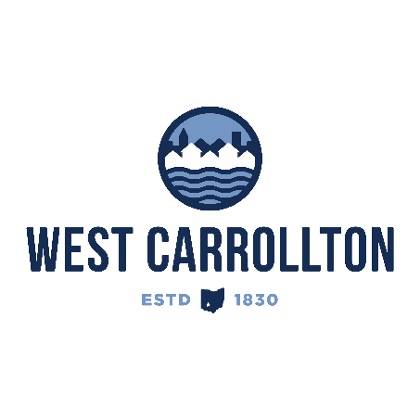

PLANNING COMMISSION

NOTICE OF PUBLIC HEARING

**Case No.:** PUD-25-1

Western Lakes Recreational District

**Meeting Date**: Thursday, September 18, 2025

**Time**: 6:30 p.m.

**Place:** City Council Chambers – Civic Center, 300 E. Central Avenue

Notice is hereby given that a Public Hearing will be held by the City of West Carrollton Planning Commission in the City Council chambers at the Civic Center, located at 300 East Central Avenue, on Thursday, September 18, 2025, at 6:30 p.m., to consider an application by Barrett Paving Materials INC, 8590 Bilstein BLVD, Hamilton, Ohio 45015, agent for the property owners Barrett Paving Materials Inc, PO Box 13671, Dayton, Ohio 45413, B and G Bituminous Company nka Barrett Paving Materials INC, PO Box 13671, Dayton, Ohio 45413, Heavin Farm II LLC, 6960 Rosecliff PL, Dayton, Ohio 45459, and Jane D Heavin, 6960 Rosecliff PL, Dayton, Ohio 45459, to approve a Preliminary Planned Unit Development (PUD) Plan and amend the Official Zoning Map of the city by rezoning approximately 433 acres along Farmersville-West Carrollton Road from LD Limited Development District, M2 Manufacturing District, and M3 Rural Manufacturing District to Planned Unit Development (PUD) District.

The proposed application may be examined at the City of West Carrollton Planning and Community Development Department located at 300 E. Central Avenue from Monday through Friday, 8 a.m. to 4:30 p.m., or on the City’s website at [www.westcarrollton.org/planning-commission](http://www.westcarrollton.org/planning-commission/). If you have questions or need more information, please email [plan@westcarrollton.org](mailto:plan@westcarrollton.org) or call 937-859-5783.