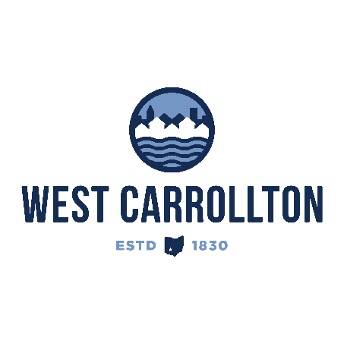

PLANNING COMMISSION

NOTICE OF PUBLIC Meeting

**Case No.:** SP-25-1

5995 Student Street

**Meeting Date**: Thursday, July 17, 2025

**Time**: 6:30 p.m.

**Place:** City Council Chambers – Civic Center, 300 E. Central Avenue

Notice is hereby given that a public meeting will be held by the City of West Carrollton Planning Commission at the Civic Center located at 300 East Central Avenue on Thursday, July 17, 2025 at 6:30 p.m., to consider an application by Michael Huff, Levin-Porter Architects, 3011 Newmark Drive, Miamisburg, OH, 45342, agent for the property owner, West Carrollton Board of Education, 430 E. Pease Ave., West Carrollton, OH, 45449, for a Site Plan application to construct an new baseball field, press box and tennis courts.

The proposed application may be examined at the City of West Carrollton Planning and Community Development Department located at 300 E. Central Avenue from Monday through Friday, 8 a.m. to 4:30 p.m., or on the City’s website at [www.westcarrollton.org/planning-commission](http://www.westcarrollton.org/planning-commission). If you have questions or need more information, please email [plan@westcarrollton.org](mailto:plan@westcarrollton.org) or call 937-859-5783.