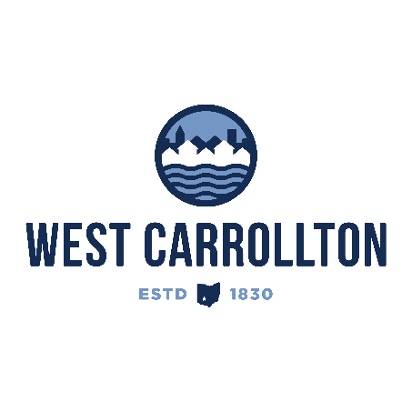

PLANNING COMMISSION

NOTICE OF PUBLIC MEETING

**Case No.:** SV-25-1

**Meeting Date**: Thursday, June 26, 2025

**Time**: 6:30 p.m.

**Place:** City Council Chambers – Civic Center, 300 E. Central Avenue

Notice is hereby given that a public meeting will be held by the City of West Carrollton Planning Commission at the Civic Center located at 300 East Central Avenue on Thursday, June 26, 2025 at 6:30 p.m., to consider a petition by the City of West Carrollton, 300 E. Central Ave., West Carrollton, Ohio 45449, for the vacation of 0.841 acres of unneeded Right of Way which will be combined with PT Lot 2500 located at 1000 E. Dixie Drive for the purpose of development of said property.

The proposed application may be examined at the City of West Carrollton Planning and Community Development Department located at 300 E. Central Avenue from Monday through Friday, 8 a.m. to 4:30 p.m., or on the City’s website at [www.westcarrollton.org/planning-commission](http://www.westcarrollton.org/planning-commission/). If you have questions or need more information, please email [plan@westcarrollton.org](mailto:plan@westcarrollton.org) or call 937-859-5783.