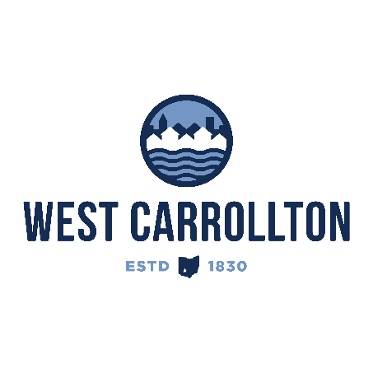

PLANNING COMMISSION

NOTICE OF PUBLIC Meeting

**Case No.:** SSP-25-1

5833 Student Street

**Meeting Date**: Thursday, May 15, 2025

**Time**: 6:30 p.m.

**Place:** City Council Chambers – Civic Center, 300 E. Central Avenue

Notice is hereby given that a public meeting will be held by the City of West Carrollton Planning Commission at the Civic Center located at 300 East Central Avenue on Thursday, May 15, 2025 at 6:30 p.m., to consider an application by Michael Huff, Levin-Porter Architects 3011 Newmark Drive, Miamisburg, OH, 45342, agent for the property owner, West Carrollton Board of Education, 430 E. Pease Ave., West Carrollton, OH, 45449, for a Special Sign Package application for the new middle school and high school, grades 7-12, on property located at 5833 Student Street.

The proposed application may be examined at the City of West Carrollton Planning and Community Development Department located at 300 E. Central Avenue from Monday through Friday, 8 a.m. to 4:30 p.m., or on the City’s website at [www.westcarrollton.org/planning-commission](http://www.westcarrollton.org/planning-commission). If you have questions or need more information, please email [plan@westcarrollton.org](mailto:plan@westcarrollton.org) or call 937-859-5783.