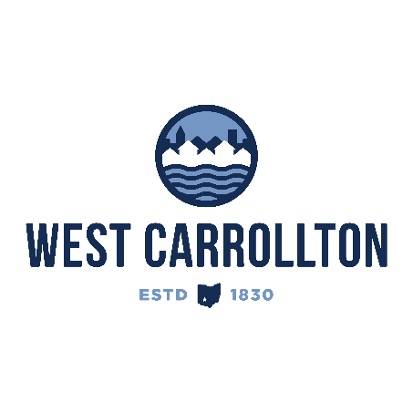

PLANNING COMMISSION

NOTICE OF PUBLIC HEARING

**Case No.:** CU-25-1

340 Gargrave Road

**Meeting Date**: Thursday, February 20, 2025

**Time**: 6:30 p.m.

**Place:** City Council Chambers – Civic Center, 300 E. Central Avenue

Notice is hereby given that a Public Hearing will be held by the City of West Carrollton Planning Commission in the City Council chambers at the Civic Center, located at 300 East Central Avenue, on Thursday, February 20, 2025, at 6:30 p.m., to consider an application by City Electric Supply Co., 3450 Needmore Road, Dayton, OH 45414, agent for the property owner, Target Property Management LLC, Centerville, Ohio 45458, for approval of a conditional use for warehousing on property located at 340 Gargrave Road.

The proposed application may be examined at the City of West Carrollton Planning and Community Development Department located at 300 E. Central Avenue from Monday through Friday, 8 a.m. to 4:30 p.m., or on the City’s website at [www.westcarrollton.org/planning-commission](http://www.westcarrollton.org/planning-commission/). If you have questions or need more information, please email [plan@westcarrollton.org](mailto:plan@westcarrollton.org) or call 937-859-5783.