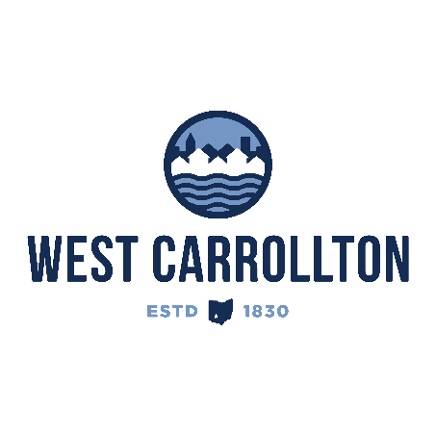

PLANNING COMMISSION

NOTICE OF PUBLIC MEETING

**Case No.:** S-24-3

1100 E. Dixie Dr.

**Meeting Date**: Thursday, December 19, 2024

**Time**: 6:30 p.m.

**Place:** City Council Chambers – Civic Center, 300 E. Central Avenue

Notice is hereby given that a public meeting will be held by the City of West Carrollton Planning Commission at the Civic Center located at 300 East Central Avenue on Thursday, December 19, 2024 at 6:30 p.m., to consider an application by The City of West Carrollton, 300 E. Central Ave, West Carrollton, Ohio 45449, for approval of a subdivision of property located at 1100 E. Dixie Dr., West Carrollton, OH 45449 for a new quick service restaurant (Culver’s).

The proposed application may be examined at the City of West Carrollton Planning and Community Development Department located at 300 E. Central Avenue from Monday through Friday, 8 a.m. to 4:30 p.m., or on the City’s website at [www.westcarrollton.org/planning-commission](http://www.westcarrollton.org/planning-commission/). If you have questions or need more information, please email [plan@westcarrollton.org](mailto:plan@westcarrollton.org) or call 937-859-5783.