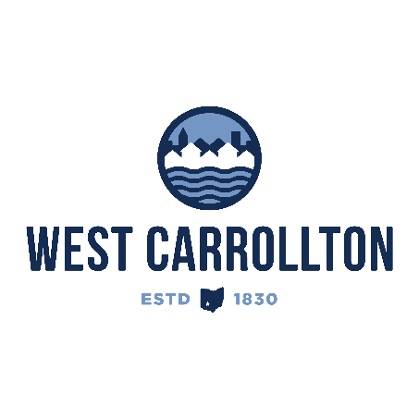

PLANNING COMMISSION

NOTICE OF PUBLIC meeting

**Case No.:** SSP-24-1

2100 S Alex Road

**Meeting Date**: Thursday, July 18, 2024

**Time**: 6:30 p.m.

**Place:** City Council Chambers – Civic Center, 300 E. Central Avenue

Notice is hereby given that a public meeting will be held by the City of West Carrollton Planning Commission at the Civic Center located at 300 East Central Avenue on Thursday, July 18, 2024, at 6:30 p.m., to consider an application by Skilken Gold, 4270 Morse Road, Columbus, Ohio 43230, agent for the property owner, Watertower Partners, LLC, 1007 Pearl Street – Suite 252, Boulder, CO 80302, for approval of a Special Sign Package application for Sheetz convenience store and fuel sales located at 2100 S. Alex Road.

The proposed application may be examined at the City of West Carrollton Planning and Community Development Department located at 300 E. Central Avenue from Monday through Friday, 8 a.m. to 4:30 p.m., or on the City’s website at [www.westcarrollton.org/planning-commission](http://www.westcarrollton.org/planning-commission/). If you have questions or need more information, please email [plan@westcarrollton.org](mailto:plan@westcarrollton.org) or call 937-859-5783.