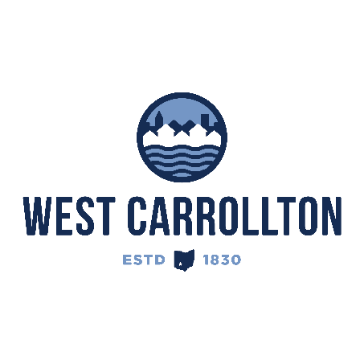

PLANNING COMMISSION
NOTICE OF PUBLIC meeting

Case No.: S-24-2
2100 S Alex Road

Meeting Date: Thursday, July 18, 2024

Time: 6:30 p.m.

Place: City Council Chambers – Civic Center, 300 E. Central Avenue

Notice is hereby given that a public meeting will be held by the City of West Carrollton Planning Commission at the Civic Center located at 300 East Central Avenue on Thursday, July 18, 2024, at 6:30 p.m., to consider an application by Skilken Gold, 4270 Morse Road, Columbus, Ohio 43230, agent for the property owner, Watertower Partners, LLC, 1007 Pearl Street – Suite 252, Boulder, CO 80302, for approval of a subdivision of property located at 2100 S. Alex Road for Sheetz convenience store and fuel sales.

The proposed application may be examined at the City of West Carrollton Planning and Community Development Department located at 300 E. Central Avenue from Monday through Friday, 8 a.m. to 4:30 p.m., or on the City’s website at www.westcarrollton.org/planning-commission. If you have questions or need more information, please email plan@westcarrollton.org or call 937-859-5783.

