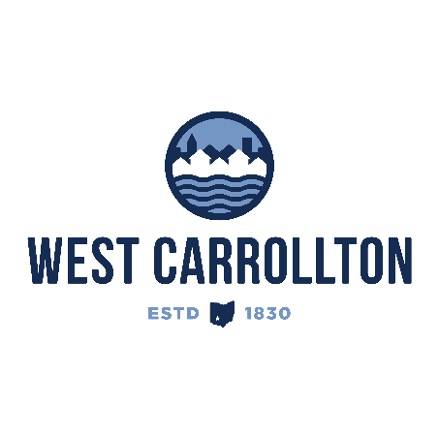

PLANNING COMMISSION

NOTICE OF PUBLIC MEETING

**Case No.:** CC-24-3

1100 E. Dixie Dr.

**Meeting Date**: Thursday, August 1, 2024

**Time**: 6:30 p.m.

**Place:** City Council Chambers – Civic Center, 300 E. Central Avenue

Notice is hereby given that a public meeting will be held by the City of West Carrollton Planning Commission at the Civic Center located at 300 East Central Avenue on Thursday, July 18, 2024 at 6:30 p.m., to consider an application by McCON Building Corporation, 1059 Circle Drive, Highland, WI, 53543, agent for the property owner, MD Restaurant Group, 1750 E. Golf Rd., Suite 320, Schaumburg, IL 60173, for approval of a site plan for the construction of a new quick service restaurant (Culver’s) on property located at 1100 E. Dixie Dr., West Carrollton, OH 45449.

The proposed application may be examined at the City of West Carrollton Planning and Community Development Department located at 300 E. Central Avenue from Monday through Friday, 8 a.m. to 4:30 p.m., or on the City’s website at [www.westcarrollton.org/planning-commission](http://www.westcarrollton.org/planning-commission/). If you have questions or need more information, please email [plan@westcarrollton.org](mailto:plan@westcarrollton.org) or call 937-859-5783.