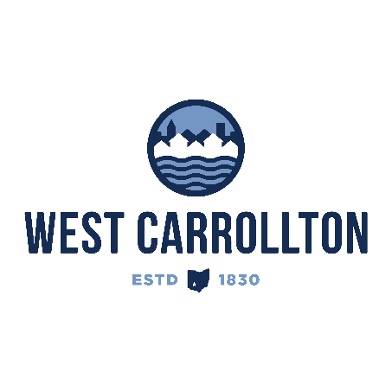

PLANNING COMMISSION

NOTICE OF PUBLIC MEETING

**Case No.:** CC-24-1

801 E Dixie Drive

**Meeting Date**: Thursday, July 18, 2024

**Time**: 6:30 p.m.

**Place:** City Council Chambers – Civic Center, 300 E. Central Avenue

Notice is hereby given that a public meeting will be held by the City of West Carrollton Planning Commission at the Civic Center located at 300 East Central Avenue on Thursday, July 18, 2024 at 6:30 p.m., to consider an application by Shannon Kennedy, Jeffrey A. Scott Architects, 32316 Grand River Ave Suite 200, Farmington, MI 48336, agent for the property owner, SRI Real Estate Properties LLC, 135 Rockaway Turnpike #10, Lawrence, NY 11559, for approval of a site plan for improvements to the building and site to be occupied by a quick service restaurant (Dunkin’) on property located at 801 E Dixie Drive, West Carrollton, OH 45449.

The proposed application may be examined at the City of West Carrollton Planning and Community Development Department located at 300 E. Central Avenue from Monday through Friday, 8 a.m. to 4:30 p.m., or on the City’s website at [www.westcarrollton.org/planning-commission](http://www.westcarrollton.org/planning-commission/). If you have questions or need more information, please email [plan@westcarrollton.org](mailto:plan@westcarrollton.org) or call 937-859-5783.