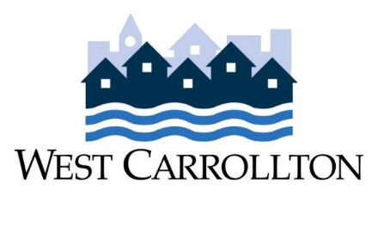
PROPERTY MAINTENANCE
GRANT PROGRAM
APPLICATION FORM

Property Address ____________________________________________________________________

Applicant Name _____________________________________________________________________

Description of work to be completed: ___________________________________________________

___________________________________________________

Social Security Number ________ - ________ - _______ Date of birth: ____________________

Disabled head of household? Yes _______ No _______

If yes, nature of disability: _____________________________________________________________

Home phone: _____________________ Work (or other phone): _________________________

Total number in applicant’s household: _______________________

Below, list each household member starting with the applicant’s name first then list from oldest person to youngest person.

Name | Relationship to Applicant | Age | Monthly Income | Income Source  (See below)
Income Source: Job, Social Security, ADC, Child Support, etc. Enter “none” if person has no income. Attach at least one document (pay stub, W-2, etc.) showing source of and amount of income, if applicable, for each person.
Additional Information applicant wishes to provide about income or situation:

Applicant Agreement:

I will obtain all necessary permits prior to completing repairs and provide documentation of payment for reimbursable expenses and any other documentation as required by the City. Reimbursement will be made after the completion of the repairs and satisfactory inspection by the City.

_____________________________________________________ __________________________________
Applicant’s Signature Date

Approved? Yes _______ No _______ Reason: __________________________________________

