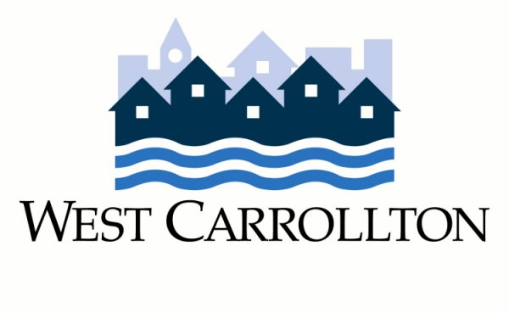

Consent to Inspect

I, _______________________________________________ (please print), being the owner of the rental unit and/or rental property located at ________________________________________ (full street address) in West Carrollton, Montgomery County, Ohio, understand that the City of West Carrollton’s Residential Rental Registration and Education Program as provided in Ordinance No. 6373 requires the City to perform periodic inspections of the exterior of residential rental units/property, and of interior common areas of multi-family residential rental properties. By affixing my signature below, I hereby state that I have read and understand the following:
- I understand that the purpose of the inspection is narrowly focused to ensure that the residential rental unit(s)/property complies with minimum property maintenance standards established by the City of West Carrollton’s codified ordinances.
- I understand that if violations of the codified ordinances are discovered, the City of West Carrollton may be required to re-inspect my residential rental unit(s)/property at a later date to ensure the violations are corrected. I also understand that a re-inspection fee as provided in Chapter 37: General Fee Schedule will be assessed if violations are not corrected after the first follow-up inspection.
- I understand that either I, my assigned agent, and/or tenant must accompany the City of West Carrollton code enforcement officer during the inspection or re-inspection.
- I understand that I have the right to refuse the inspection of my residential rental unit(s)/property without a search warrant, as stated in the Fourth Amendment of the Constitution of the United States of America and the State of Ohio.
- I understand that I have the right to receive and read Ordinance No. 6373, which is available online at www.westcarrollton.org/rental-registration-program or upon request from the City of West Carrollton Planning & Community Development Department.
With full understanding and knowledge of the above, I hereby authorize officers and/or agents of the City of West Carrollton to enter upon my property and/or premises at the address noted above for the purposes of conducting an inspection of my residential rental unit(s)/property.

Signed: ___________________________________ Date: ___________ Time: __________
Printed: ___________________________________
Witness: __________________________________
Witness: __________________________________

