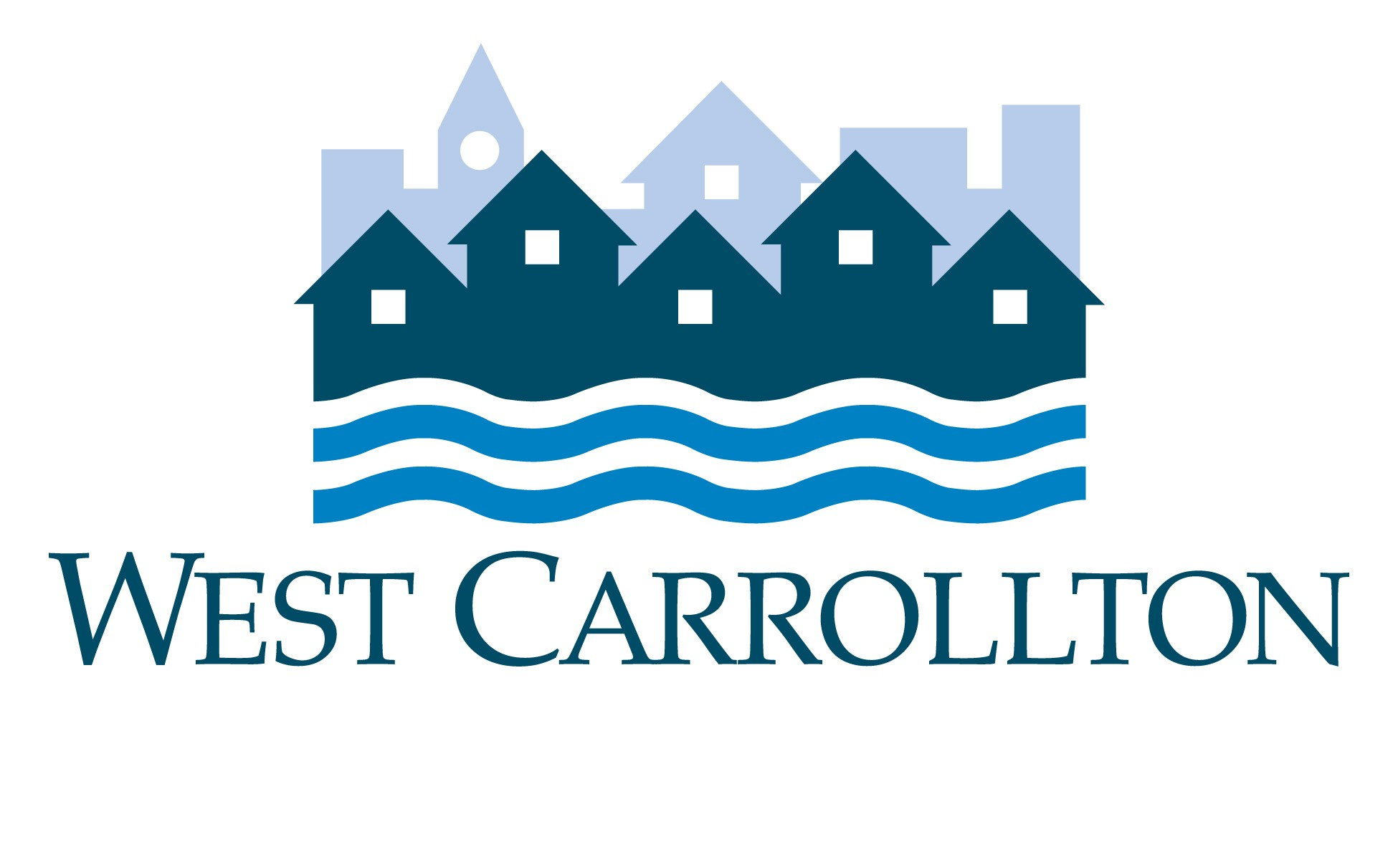

CITY OF WEST CARROLLTON
BOARD OF ZONING APPEALS
AGENDA

August 11, 2022 – 6:30 p.m.
City Council Chambers
Civic Center – 300 E. Central Avenue

MEETING CANCELLED

- CALL TO ORDER

- PLEDGE OF ALLEGIANCE

- ROLL CALL

- APPROVAL OF AGENDA

5. APPROVAL OF MINUTES AND RESOLUTIONS

6. PUBLIC HEARINGS

7. DECISION ITEMS

8. DISCUSSION ITEMS

9. COMMENTS BY THE AUDIENCE

10. ADJOURNMENT

