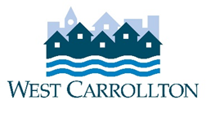

CITY OF WEST CARROLLTON
BOARD OF ZONING APPEALS

AGENDA

June 9, 2022 - 6:30 p.m.
City Council Chambers
Civic Center - 300 E. Central Avenue

- CALL TO ORDER

- PLEDGE OF ALLEGIANCE

- ROLL CALL

- APPROVAL OF AGENDA

- APPROVAL OF MINUTES AND RESOLUTIONS
  - Minutes of September 10, 2020 meeting (Folker, Myers, Potts, Bates)

- PUBLIC HEARINGS

- DECISION ITEMS
  - PM-22-1 – 215 W. Circle Ave (Demolition Authorization)
  - Election of Officers
  - 2022 Schedule of Meetings

- DISCUSSION ITEMS
- Report by Director
  - Briefing by City Council representative(s)
  - Unscheduled business
  - Next meeting: July 14, 2022

- COMMENTS BY THE AUDIENCE

- ADJOURNMENT

