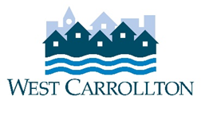

CITY OF WEST CARROLLTON
BOARD OF ZONING APPEALS

AGENDA

MEETING CANCELLED

May 12, 2022 - 6:30 p.m.
City Council Chambers
Civic Center - 300 E. Central Avenue

- CALL TO ORDER

- PLEDGE OF ALLEGIANCE

- ROLL CALL

- APPROVAL OF AGENDA

- APPROVAL OF MINUTES AND RESOLUTIONS

- PUBLIC HEARINGS

- DECISION ITEMS

- DISCUSSION ITEMS
- Report by Director
  - Briefing by City Council representative(s)
  - Unscheduled business
  - Next meeting: June 9, 2022

- COMMENTS BY THE AUDIENCE

- ADJOURNMENT

