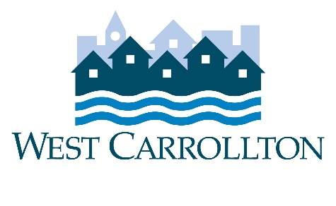

CITY OF WEST CARROLLTON
PLANNING COMMISSION

AGENDA

March 2, 2023

6:30 p.m.
City Council Chambers
Civic Center - 300 E. Central Avenue

- CALL TO ORDER

- PLEDGE OF ALLEGIANCE

- ROLL CALL

- APPROVAL OF AGENDA

- APPROVAL OF MINUTES AND RESOLUTIONS

- PUBLIC HEARINGS

- DECISION ITEMS

- DISCUSSION ITEMS
  - Report by Director
  - Briefing by City Council representative(s)
  - Unscheduled Business
  - Next Meeting: April 6, 2023

- COMMENTS BY THE AUDIENCE

10. ADJOURNMENT

