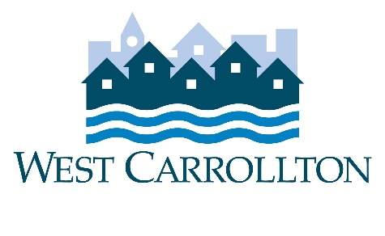

CITY OF WEST CARROLLTON
PLANNING COMMISSION

AGENDA

February 2, 2023

6:30 p.m.
City Council Chambers
Civic Center - 300 E. Central Avenue

- CALL TO ORDER

- PLEDGE OF ALLEGIANCE

- ROLL CALL

- APPROVAL OF AGENDA

- APPROVAL OF MINUTES AND RESOLUTIONS
  - Minutes of September 15, 2022

- PUBLIC HEARINGS
  - CU-23-1, 2100 S. Alex Rd. (GetGo Convenience Store/Fuel Station)

- DECISION ITEMS
  - Election of Officers
  - Approval of 2023 Meeting Schedule

- DISCUSSION ITEMS
  - APA Planning Officials Training Program
  - Report by Director
  - Briefing by City Council representative(s)
  - Unscheduled Business
  - Next Meeting: March 2, 2023

- COMMENTS BY THE AUDIENCE

10. ADJOURNMENT

